Client: Me
Advisor: Ms.Jones
Problem: through taskmanager there is very little option to record, store or view data at periods longer than a minute or so due to the refresh and the display being unable to display the data. I want to create a program that is modifiable in order to store and bring up previous data in order to find trends in data as well as provide an insight into how a computer may fare over certain periods of high-intesity or low intensity usage, I.E memory leaks.

!!
Victory conditions: real-time graph, reasonable trend analysis, store variables, easy to use, modifiable
!!

How will this be implemented?

Will attempt to use standard java libraries in order to access data

Data will be stored in either an object for maximum flexibility or as a double array in order to keep percentages and other variables.

Data will be displayed using java swing methods

There will be multiple ways of accessing the data and their representation.

Magnitude of usage may be show in colored text that can be modifiable

Graph background and line color may be changeable (if I have time)

May implement multithreading to draw graph as well as another thread to record
data

Dec.24 (my planning process)

Visual representation by color bar or circle of how much a single process is using

did research on how to acquire low-level information I.E Cpu usage and ram usage, stackoverflow had a nice article on the subject.

May do ram usage and Cpu usage over time in a graph fashion as getting different applications seems to be impossible with the java language

Ram and Cpu usage over time is now the main goal and I will be using swing’s line to help chart the graph. Input output will be implemented as a way to track trends. Data will be recorded per second as well as being adjustable but the graph should still result in the same shape just varying accuracies as I average out the recordings. Data will be stored as a double array and I will have varying methods of displaying the graphs, I.E by amount at percentage of usage, time of certain percentage range, data points, I may make the storage of data as node in order to keep most flexibility, may modify as I go.

Found some nifty lines of code that use default java classes, in java.lang.managment and java.lang.reflect that acquire all the info I need.

Created and object class that uses aforementioned code to read the method names that will be acquired and then further allocates them to their destination
Dec.25 started testing of the set class based on a snapshot of the system at that period in time hence snapshot I my object constructor. I created a string to show that there may be an error with the code by catching runtime error as well as having it set to default that something went amiss when storing the value
Created exception string even though values stored fine, am now testing for bugs
2variables not going to expected places :solved charAt() used in wrong places

Idea: superimpose second graph in a different color to better see trends
*find out how to call java garbage collector
Addition: create a graph based on a set range

How will I change menu’s? will it be panel with menu options top and Panel that changes based on radio button, clear previous add new, setvisible()

Dec.26
Top bar
changes what main displays, (real-time, stored, by set (range), options
side bar:
real-time displays total runtime, current data and a graph over time, export
stored allows you to add graph data and modify what range you are interested in (By graph?)
options holds: scale of graph (x and y), interval of data recording (may need a restart), color, location of settings file, calculate (subtract the resources java uses)

**change color from percentage to severity

Worked out more of the details of the classes and etc.
The Linked List is only used for export purposes and regraphing, data will go straight to graph to be graphed
Changing graph interval, domain, or range will cause a regraph in which I will re render the graph. Interval for storage will be effective immediately by having the time check access the settings object. Color change will also be a regraph.

Dec.27 reorganized and created classes, created infinite data gather.

Dec.29 created top layer of JFrame and worked on panels to hold graphs
The save text field does not set size properly and I’ll solve that later
Set size no longer works if you are using it in a panel that has been borderlayouted, the only way to adjust things is to create a new non borderlayout Panel and then Panel add your way to success or use GridLayout

Changing export options to graph bottom instead of left
Radio buttons for cpu ram and physical memory go on left
Color will represent the type of graph, green CPU, blue RAM, red CPU space; I will add/ subtract values of rgb respectively to display the set data

May not have export of settings as it seems a bit worthless now -_-

Removed settings and put it on the left sidebar of real time
Using a combo box to navigate through all of the graph info on display data

Wish me luck me
Dec.30:finished up a bit more in set data am now working on exporting data
Finshed export of data but Cpu information could use some extra clean up
Finished Import forgot to record, all systems green to begin data plotting

Dec. 31 Happy New Year soon!
Gonna work on graph drawing first, figure how easy that is then find dimension and hopefully finish that and begin documentation

Debating necessity of double panel. May incorporate all into one frame and have realtime running in the background
Debating how I will redraw graph with info in super if I can’t throw an error
Making a double array would be extremely taxing on system and not having in Frame means not having in set data, will likely merge in v2.0 (aka when I have time)

MERGE PANELS()
FIND DIFFERENCE IN HDD AND FREESPACE
Note to self you can only draw in a panel when that panel has decided the position of the color, I.E. cneter or gridLayout
Graph JFrame will do all the interval checks, calculations will do all the adjustments for location.

In order to display multiple line, setvisible first then change and set the next one visible
Needed to create a settings file and various methods to throw those around to get the restrictions for the graph
Finished graph calculations, had error with dividing long variables, casting them as doubles will solve it
Needed to set the entire thing as visible to update the changes by graphing

Set data needed small modification to the graph in order to display.
Jan.2 fixed bugs in the display of loading a graph, main cause was no default display and an improper start time
Jan.4
Worked on documentation, started on Part A the basic planning
Jan.5
Worked on more documentation specifically B design, not change list
Jan.6 worked on planned record
Jan.7
making 3 different programs as my final proto
- Realtime with overlay graph (RO)
-1 second delay, close to first prototype in design
-multi thread data record and one thread for plotting
-multiple colors
-scrollbar menu
- Realtime (max accuracy)(just record data)(RMax)
-simple display
-few options
-records in ms
- Plot(low usage)(remove lists after draw and keep file path)(Plot)
-removes list after done drawing
-creates a general properties menu
-has all modification

For RMax the diagram of data will go
Initizalize
-stop
-start
-true then
-time
-true then
-get
-check
-draw
-add

For Plot
-wait
-find
-Add to list
-save variables
-assign color
-assign menu spot
-draw and discard
-if settings change
-get graphs and draw one by one

For RO
Mix of above with the graphs being threaded if they wish to load one.

Jan.8 Worked on creating more diagrams and planning out my programs logic

Feb.2 Welcome back world! Took a nice long exam study time in order to raise marks, as such process 10+ are delayed by about a month
Goals: finish decisions to be made and get ready for some c#. by this point my planning should be mostly done.

Feb.3 started playing with C#, still need to figure out the various commands to add panels and create my own panels and etc.

Figured out manual adds do not process until run
http://www.c-sharpcorner.com/uploadfile/mahesh/panel-in-C-Sharp/

Feb.4 Figured out panel system, read online that you need to create a panel to add multiple different objects and I will be trying that next

Feb.5 Continued to work with panels, figured nothing out, also investigated ib notes
Feb.6 Asked parent and told me that a studio is used to streamline the GUi process and that making my own components is difficult and the gui will always be complicated

Feb.7 working on creating a storage object for the cpu and other stats
http://stackoverflow.com/questions/278071/how-to-get-the-cpu-usage-in-c
http://stackoverflow.com/questions/1393711/get-free-disk-space
http://stackoverflow.com/questions/105031/how-do-you-get-total-amount-of-ram-the-computer-has

Category names I want are Process and memory for Performance information
For HDD space I need DriveInfo
Feb.8 Figured out that I was calling process not processor which gave me the wrong result, finished up using Driveinfo in order to record total and used, need to figure out how to get accurate total ram and available ram

Got total ram by use of referencing Microsoft.VisualBasic.dll and was able to calculate a close average with help of Available Bytes in Performance Counter.

Feb.9 Goal is to understand the Graph WPF and see how I may be able to use it, else find a trend graph. Need to learn database by object.
//not used as I figured out graph series class.
https://msdn.microsoft.com/en-us/magazine/ff714591.aspx

Feb.10
//not used in final product
https://msdn.microsoft.com/en-us/library/ms227436(v=vs.140).aspx
Example so Analyze it!
https://msdn.microsoft.com/en-us/library/ms178538(v=vs.100).aspx

given up and am going to use something similar to my java with lines
//not used as I figured out Microsoft series
https://msdn.microsoft.com/en-us/library/aa287522(v=vs.71).aspx

By sheer amazement of myself I have created a component by simply creating a simple panel class and not one of their component classes.

Feb.11
//append code
worked on the interaction between the classes in preparation for code

Figured out how to create and add to a series

Feb.12 displayed information on graph with a constantly changing domain, need to adjust to make it locked or only extend when data extends
ITS ALIVE
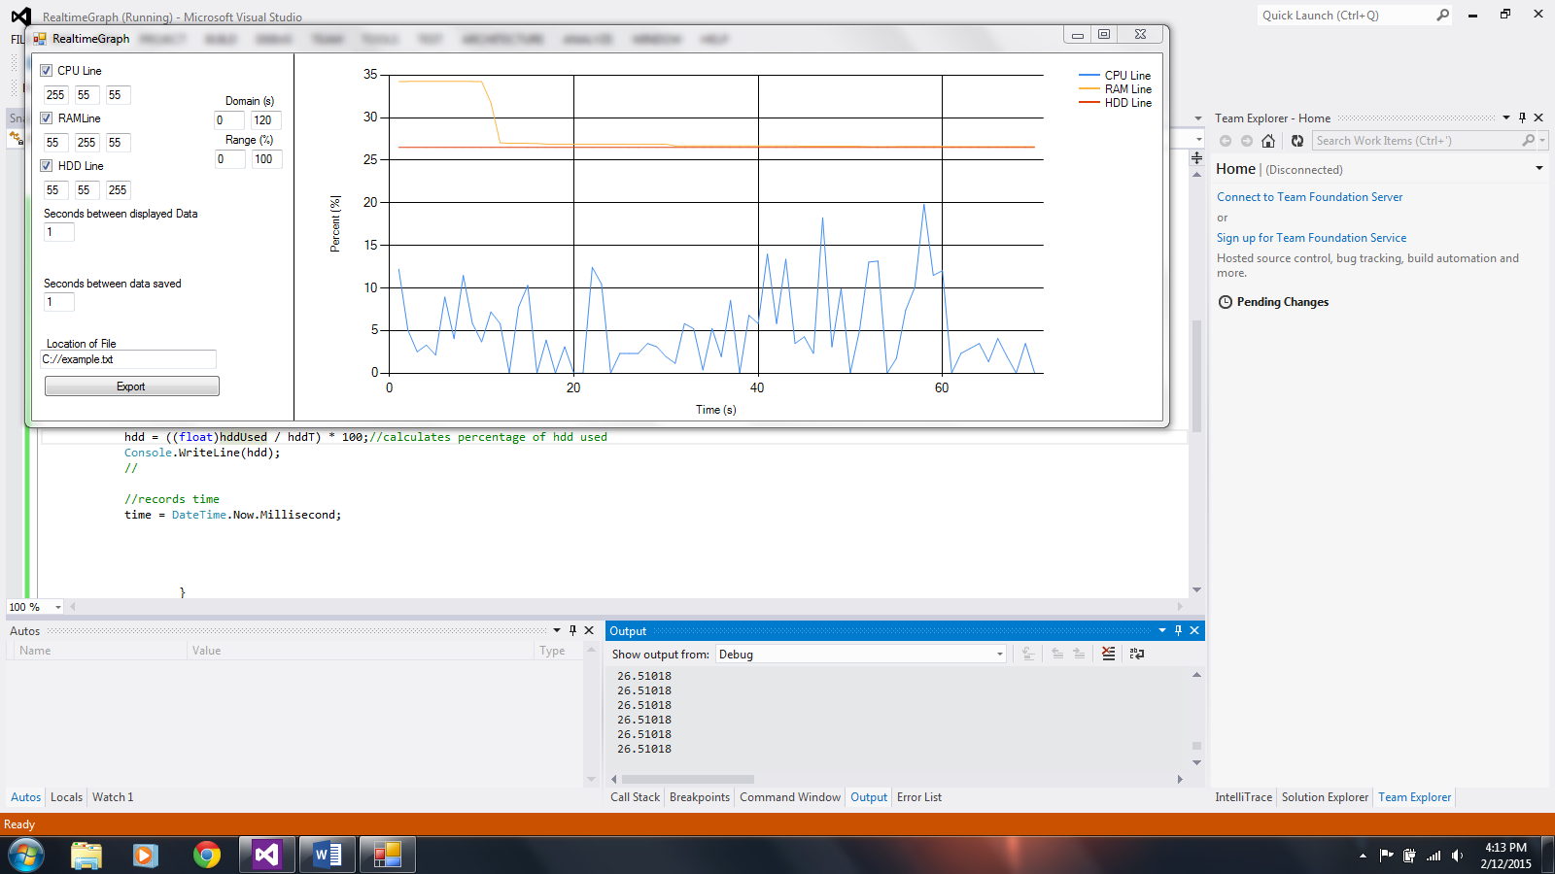

Worked on setting up timers for the graph as well as implementing show/hide feature
Implemented show/hide and firs timer
Feb.13
Goal: finish realtime graph
Feb.14 take a break and do what I can in studio to start making loadgraph
Feb.15 decided to finish loadgraph and then merge the two programs by making them panels, finished the panel layout of the selections on the combobox
Feb.16 Start filling in the meat by writing import code and combobox decision code
-problems the StreamReader.read() method returns values as int and therefore I need to make a converter to values
Feb.17 many formatting issues with the text document, including \n being a Unicode value as well as a \(10) appearing after a new line and at the end of the text document, in which I added a peek if that broke the loop. Added color randomization as well as implemented in the constructor of the comboboxgraph class setting the graphs as lines and not bars. Finished Adding graphs
Feb.22 forgot to be keeping a log, finished loadgraph visibility tracker yesterday, the other actionlisteners were completed 2 days ago. Today I am trying to merge the graphs
-Tackled a bug in which the timer required a component for way too long (3 hours)
- bug in which data was recorded twice
-added panel via studio, ended up in a crash loop as I tried to remove it because it was recording in studio
-rewrote the program working for now
-finsihed adding both realtime and loadgraph
-remember to add remove graph function to loadgraph later (need to finish documentation first)
Feb.23 added the remove feature into loadgraphs. Start work on documentation
Part A.
*********PREVIOUS PROJECT BELOW**********
Client: me (Lintao Yin) advisor: Ms. Jones
Problem: Trying to compare video cards is extremely annoying and as such I plan on making a program that will automatically compare and print results of the cards I enter including any data they can scrounge up from the website I will be using to compare them, videocardbenchmark.net.

Solution, compare 2 cards based on benchmarks.com’s G3D number and suggest alternatives as well as highlight them on a list. Show the differences between them based on G3D number. Show on a list based display as well as suggest links using the google search engine or maybe E-Bay.

-auto updating based on settings or click to update menu
-compare and store data.
-Create list and show data
-Suggest links and similar cards.
-limit the list to search by letters in name
- 10 or more cards add a section for them I.E. Radeon, GeForce
-suggest cards if not found.

Node based storage with nodes arranged by alphabet and G3D number
I.E. same Node with same data but it has different nodes for alphabet and next higher/lower G3D number

How will I limit based on what the text box contains? Auto-updating or button based?
Button: Just run it through the array.

Auto updating:
String.Contains() will obviously be used
Hash table, search for contains then store the node, display node
Planned Run:

On startup list possible accuracy errors from videocard benchmarks
Reads settings for card auto update, then performs, reads from local otherwise

Maximize list as well as minimize list, info for cards 1&2
Hold to select card 2
List for first cards | Display card info | Display 2nd card info | Other menu options
List with name and G3D number | Text box to grab card  Full display of available stats from video card benchmarks as well as other similar cards and links | Same as display card | Explore, random, export (single and list), reset, date last updated
Dec.15 begin planning by deciding problem and setting the ground work for all files and what data structure it may encompass as well as how to access and efficiently use the data structure. What the layout of the Jframe appears like was thought about as well as various other options for the program.

Dec.16:
How to do nodes for different G3D and string but equal same data? Pre-organized Linked List?
Create a private set command for the nodes? I.E create node, set node if larger or smaller, if not send the node down. then set the node, class stays but nodes are set.

Similar cards: go by G3D number?
Go by letter? Both?

Dec.18
Created Card object to store the video cards containing String variable name and int variable for the G3D number and a started the creation of the data structure.

Decided to switch the data structure used to store the data into a linked list instead of a binaryTree in order to retain efficiency in usage of the RAM
Also realized that node stores based on objects and may change data structure again

Dec.22
Created master array that stores all the card classes, need to decide how to store pointers LinkedList or Tree?
LinkedList

Created add process for both String and Integer LinkedLists
Compartmentalize?? (I.E make them their own methods to enable greater ease of adjustment)
Finished addition of new cards, tested by creating tester in package and running with 3 cards time to complete (G3D number) (excluding creation of cards) 20ms

Found a method of parsing html to string using in class methods and classes, copied and modified in order to just get me the text by using the doc.getText(domain,length)method
ill take you to the chart it appears in and will highlight it for you.

Dec.23 doc file stores in such a way that no spaces are present will find another way of retrieving data

Found one using straight html to string conversion, will need formatting

Will continue search

Found apache IOUtils but that needs to be installed, will consider
Realized breach of copyright oopsies ☹

